Product Name

Product Statement (e.g. "a Google-Yelp hybrid for locating doctors")

# Overview

*Why should this product exist? What are the business reasons and objectives for putting out this product?*

Consumers still face difficulties when it comes to finding a reliable doctor. This is particularly true when seeking a specialist as opposed to a generalist. If no one in that person’s social circle needs a particular specialist, the consumer is not able to find a quality doctor they can really trust.

This product will be free and as such, it will allow our brand to extend its reach and visibility in the market. It will be a strong complementary product to our existing paid offering for medical professionals.

It is expected that the release of this product will make us a trusted authority in the market for both medical professionals and consumers seeking those professionals. Building trust with both types of users will ultimately lead to increased acquisition and conversion rates.

# Project Team

*List the project team members and their roles*

* Germaine Satia - Product Manager
* John Doe - Lead Developer
* Jane Doe - UX Designer
* Erik Flowers - Scrum Master
* Jerry Cao - Content Strategist etc.

# Target Users

*Who are you designing for? What will they do with the product? When will they use the product? How will they access the product?*

* **Who:** Generally, people 25–50 years of age who make over $45k/year and are seeking a doctor.
* **What:** The site will allow search based on various criteria (zipcode, health insurance type, specialty, etc.). User can also book an appointment, view doctor’s availability.
* **When:** Most likely when it is time for an annual checkup or follow-up on an existing condition.
* **How:** Online and via an app.

# Users Problems We Will Solve

*What are the main user needs our product must address? How will the product address these issues?*

* **User Need 1:** Find a naturopathic doctor in my city

**Resolution:** The product will allow an address-based search

* **User Need 2:** Verify the reliability and trustworthiness of a doctor

**Resolution:** The product will display each doctor’s certifications and diplomas. Reviews from previous patients will also be included

* **User Need 3:** Schedule an appointment with a doctor

**Resolution:** Doctor’s availability will be displayed so user can select date and time that suits them

* **User Need 4:** Find a doctor based on my type of insurance

**Resolution:** Insurance type will be an option for search

# Core User Stories

*Describe the key functions that users will be able to perform. These core tasks must focus on functionality and should not hint at design elements. This section should include a link to the detailed user story backlog as a reference.*

* As a user I can search for a doctor by name
* As a user I can search for a doctor using my street address
* As a user I can search for a doctor based on the type of insurance
* As a user I can search for a doctor by specialty
* As a user I can schedule an appointment with a doctor
* As a user I can modify or delete my existing appointment
* As a user I can create an account
* As a user I can set-up appointment notification reminders
* As a user I can view my activity/appointment history

See [insert link to your product backlog] for a complete list of user stories and their details.

# Competitors

*List your core competitors along with a short description of about how they position themselves in the market. State whether their product is available via web, an app or both.*

#### ZocDoc

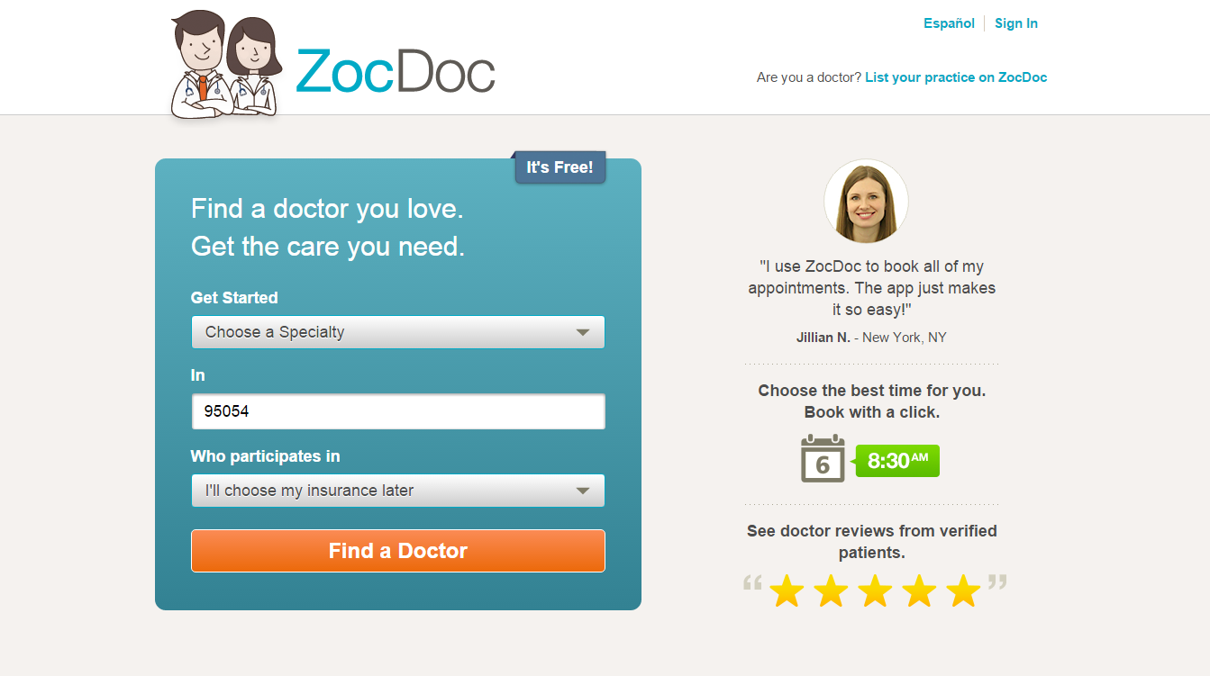

Simple and approachable homepage that immediately instructs users to start a search based on both Specialty and Insurance type. Target audience is anyone seeking a doctor in a private practice.

**Core functions available:** search, book, create account, view user reviews

**Pros:** *list any benefits from a functional or user experience perspective*

**Cons:** *list any drawbacks, from a functional or user experience perspective*

**Pricing:** *if this is a paid provide summary of pricing scheme*

#### Healthgrades

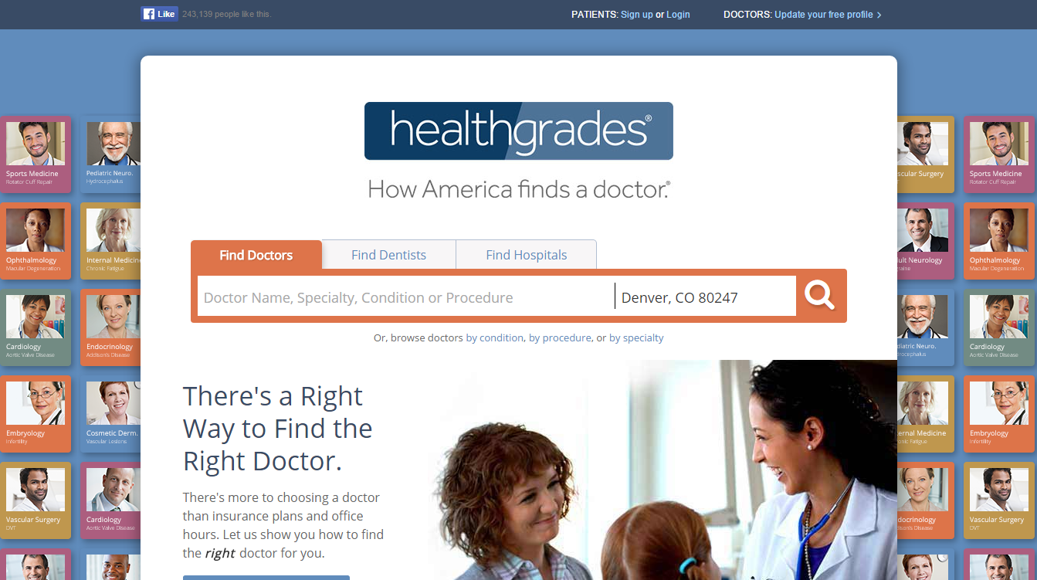

Homepage directs users to start a search immediately. Target audience is anyone seeking a doctor in a private practice or simply looking for a hospital.

**Core functions available:** search, book, create account, view user reviews

**Pros:** *list any benefits from a functional or user experience perspective*

**Cons:** *list any drawbacks, from a functional or user experience perspective*

**Pricing:** *if this is a paid provide summary of pricing scheme*

#### Sharecare

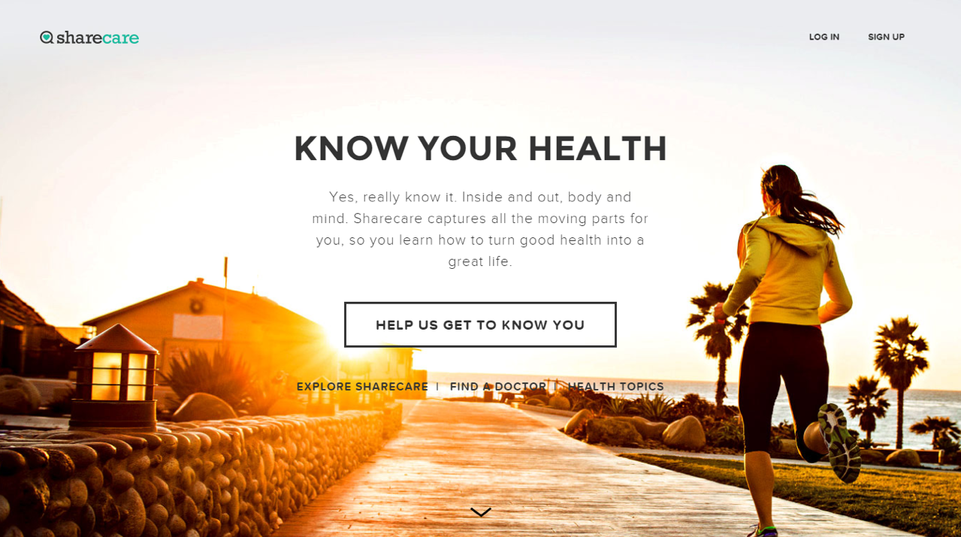

This site is an overall health resource with various value propositions: educational content and guides, search function to locate doctors, and an app that tracks stress based on voice analysis. Target audience is broader than the previous competitors. Focus is on consumers who enjoy using apps and those who are interested in being autonomous when it comes to their health.

**Core functions available:** search, book, create account, view user reviews

**Pros:** *list any benefits from a functional or user experience perspective*

**Cons:** *list any drawbacks, from a functional or user experience perspective*

**Pricing:** *if this is a paid provide summary of pricing scheme*

# Related Documentation

*List and link to any existing documentation connected to the project. You can also include documents that are still pending creation.*

* Technical Overview
* Technical Architecture
* Links to [UXPin](http://uxpin.com/?utm_source=Product%20Requirements%20Document%20Template&utm_medium=template&utm_campaign=Product%20Requirements%20Document%20Template) Prototypes
* Terms of Use
* Privacy Policy
* HIPAA Regulations
* Health Information Policy

# Pricing

*If you’re creating a paid product, explain how the market positioning  in terms of pricing. Will it be low, medium, or high-end?*

*If approximate prices are already available, include that information. In many cases the pricing becomes clear as the project progresses. The product manager should indicate that pricing is TO BE DETERMINED and follow-up with the appropriate decision-makers so that the information is added to this document as soon as it’s available.*

This product will be 100% free to all consumers. One product offering is available to everyone.

# Dependencies

*List any dependencies that might affect this project.*

*For example, are there sufficient development and UX design resources? Are there team members with a planned absence during the duration of the project (e.g. planned maternity leave)? Explain the contingency plan for accommodating the absence. Does the release of this product depend on hiring additional staff or on the release of another product?*

Development work on this project can only begin after John Doe completes the custom dev work for Company ABC. John’s anticipated availability date is June 15th.

This project will run through the summer when many team members will be taking time off. The team members should block off their vacation dates no later than May 31 to ensure that we ensure appropriate backup/coverage during each person’s absence.

# Product Release Dates

*Indicate the expected release date for the product. If there are any business dependencies (e.g. must be ready in time for a big trade show) include that information here. Information in this section may have to be verified by or updated by the Product Officer or Product VP depending on organizational structure.*

The planned release date for this product is no later than end of Q3 2017.

This date is a hard cutoff because the regional health & tech conference is in October and we will be presenting this product to attendees. The product is also essential to our Q4 customer acquisition and conversion objectives, which will subsequently influence the next round of investment fund-raising that we’ll be going for in Q1 of next year.

# Product Launch Tactics

*Provide a summary of the anticipated marketing plan for this product. If there isn’t enough visibility at the start of the project into the planned marketing tactics, leave this section empty and mark it as to be TO BE DEFINED. The Product Manager should update this section once more information is available or follow-up with Marketing and Brand team(s) to ensure that they update this section accordingly.*

*To be determined for now.*